Academic Year: 2024-25 | Year: First Year | Term: I
Roll No.: | 11
Name: | Riddhee Sandeep Kulkarni
Subject: FCP
Assignment No.: | 26
Title: | Employee Record
Date:

Contents
1. Theory (Logic) 2
2. Pseudo Code 2
3. Program Code 2
4. Output 2
5. Conclusion 2

THEORY:

This code displays employee record using structure. It includes details such as name, ID,

department, and salary.

PSEUDO CODE:

Step 1: Start

Step 2: define structure

Step 3: define main function

Step 4: accept data from user

Step 5: print output

Step 6: end

PROGRAM CODE:

#include <stdio.h>

struct Employee

{

char name[50];

int ID;

char dept[100];

float sal;

}s[10];

int main()

{

int i,n;

printf("Enter the number of employees: ");

scanf("%d",&n);

printf("Enter employee record\n\n");

printf("\n");

for(i=0;i<n;i++)

{

printf("Enter name: ");

scanf("%s",&s[i].name);

printf("Enter ID: ");

scanf("%d",&s[i].ID);

printf("Enter name of department: ");

scanf("%s",&s[i].dept);

printf("Enter salary: ");

scanf("%f",&s[i].sal);

}

printf("Employee record\n\n");

printf("\n");

for(i=0;i<n;i++)

{

printf("Name: %s\n",s[i].name);

printf("ID: %d\n",s[i].ID);

printf("Department: %s\n",s[i].dept);

printf("Salary: $%f\n",s[i].sal);

printf("\n");

}

return 0;

}

OUTPUT:

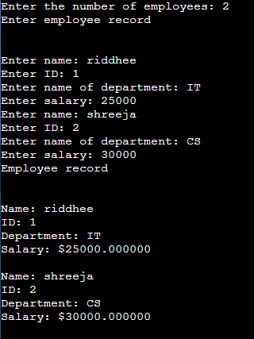

CONCULSION:

Code is run successfully, required output received

